**AWGN channel model**

In order to simulate a specific SNR point in performance simulations, the modulated signal from the transmitter needs to be added with random noise of specific strength. The strength of the generated noise depends on the desired SNR level which usually is an input in such simulations. In practice, SNRs are specified in ***dB***. Given a specific SNR point for simulation, let’s see how we can simulate an AWGN channel that adds correct level of white noise to the transmitted symbols.

[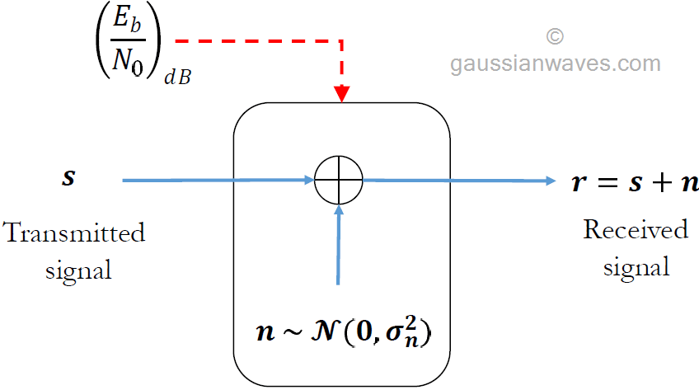](https://www.gaussianwaves.com/buy-books/)*Figure 1: Simplified simulation model for awgn channel*

Consider the AWGN channel model given in Figure 1. Given a specific SNR point to simulate, we wish to generate a white Gaussian noise vector \mathcal{N}(0,{\sigma}^2) of appropriate strength and add it to the incoming signal. The method described can be applied for both waveform simulations and the complex baseband simulations. In following text, the term SNR (***γ***) refers to ***γb = Eb/N0*** when the modulation is of binary type (example: BPSK). For multilevel modulations such as QPSK and MQAM, the term SNR refers to ***γs = Es/N0***.

**(1)**Assume, ***s*** is a vector that represents the transmitted signal. We wish to generate a vector ***r*** that represents the signal after passing through the AWGN channel. The amount of noise added by the AWGN channel is controlled by the given SNR – ***γ***

**(2)**For [waveform simulation model](https://www.gaussianwaves.com/2017/10/complex-baseband-equivalent-models/), let the given oversampling ratio is denoted as ***L***. On the other hand, if you are using the [complex baseband models](https://www.gaussianwaves.com/2017/10/complex-baseband-equivalent-models/), set ***L=1***.

**(3)** Let ***N*** denotes the length of the vector ***s***. The signal power for the vector ***s*** can be measured as,

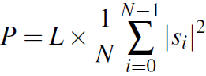

**(4)** The required power spectral density of the noise vector ***n*** is computed as

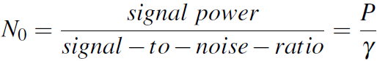

**(5)**Assuming complex IQ plane for all the digital modulations, the required noise variance (noise power) for generating Gaussian random noise is given by

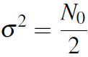

**(6)** Generate the noise vector n drawn from normal distribution with mean set to zero and the standard deviation computed from the equation given above

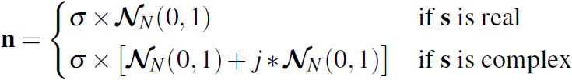

**(7)**Finally add the generated noise vector (***n***) to the signal (***s***)

equation for awgn noise channel

**Matlab code**